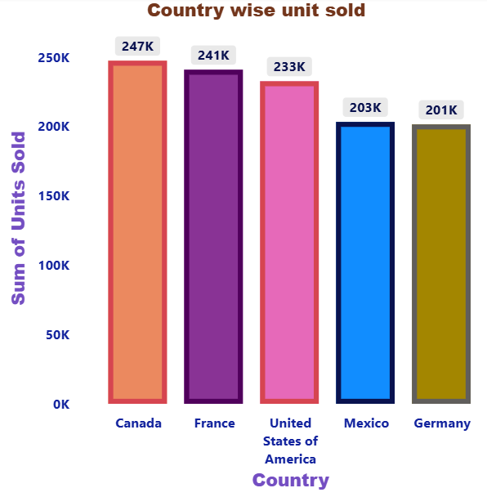

* **To Add visual**

1. Go to Report view.

2. From Visualizations, choose Clustered column chart.

3. Drag Country → X-axis (Axis).

4. Drag Units Sold (the column with Summarization = Sum) → Y-axis (Values).

To Format The Chart

* **Open the Format pane**
* **Y-axis**

Font To Bold - Size To 12 - Change the Colour of the Title

Title: On → Text: Sum of Units Sold

Font To Bold - Size TO 12 – Change the Colour of the Title

Display units: Thousands (K)

Gridlines: Disable

* **X-axis**

Font To Bold - Size To 12 - Change the Colour of the Title

Title: On → Text: Country

Font To Bold - Size TO 12 – Change the Colour of the Title

* **Data labels**

Data labels: On

Display units: Thousands

Decimal places: 0

Position: Outside end (so the label sits above each bar)

Increase Text size a bit

* **Data colours**

Data colours: On → to assign different colours per country

Columns (spacing)

Visual border/shadow (optional)

Effects ➜ Shadow/Border: On

* **General**

**Title**

Font To Bold - Size To 12 - Change the Colour of the Title

Alignment to Center

* **Save**

File ➜ Save the report.